I have included screenshots and “scripts.js” where I wrote my scripts since they’re likely easier to read than having to use this PDF where you see screenshots of radically different sizes. I needed to use this website when dealing with multiple lines of code to put them on one line or the mongo CLI wouldn’t work.

https://lingojam.com/TexttoOneLine

1. Insert all the cars using the same attributes that Sue has

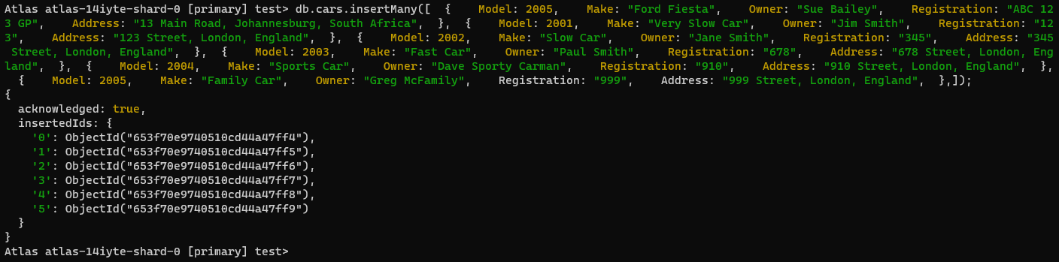

1. Find all the cars

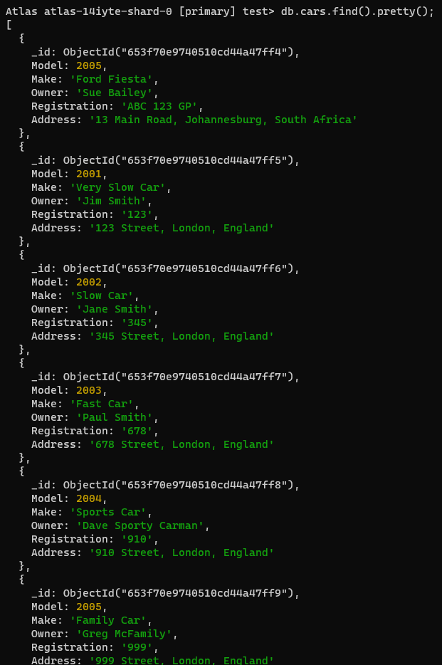

1. Update Sue’s address and surname

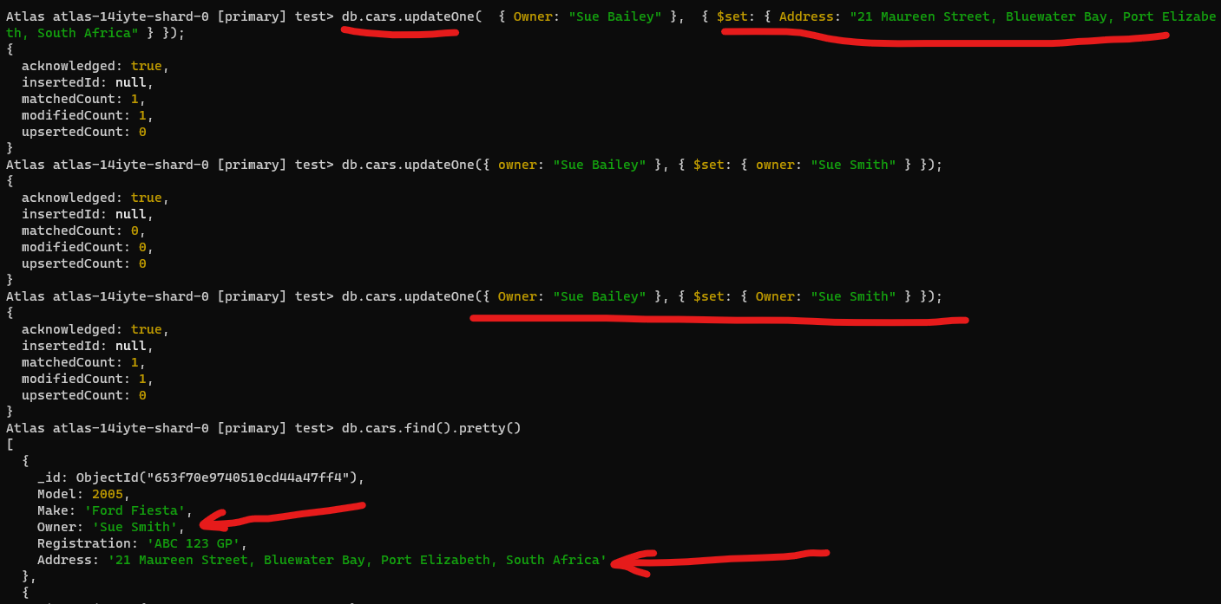

1. Find cars older than 5 years old (so made before 2018) using “lesser than”

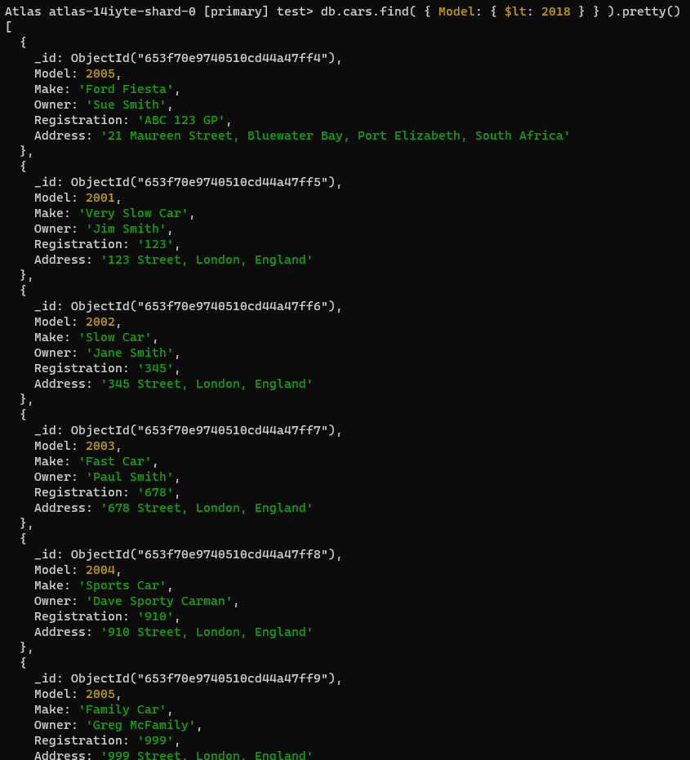

1. Add another Sue with the same surname as the recently married Sue



1. Delete the original Sue but not the new one by targeting the Object Id (similar to targeting the 100% unique primary key in an SQL database)

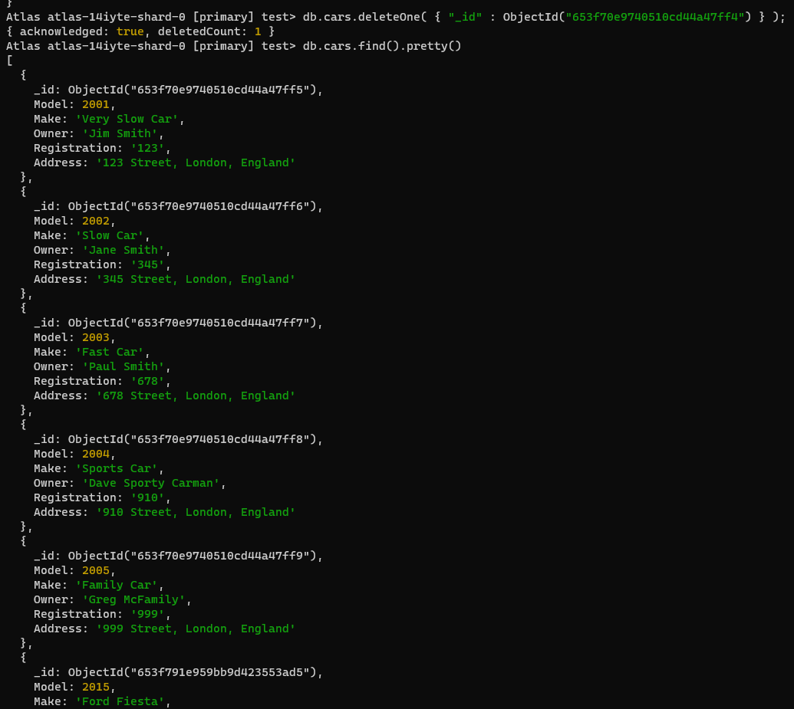

1. Add a list of previous owners to a car

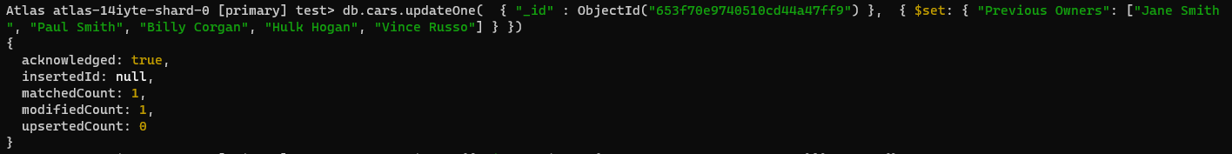

1. Show the car with its previous owners

